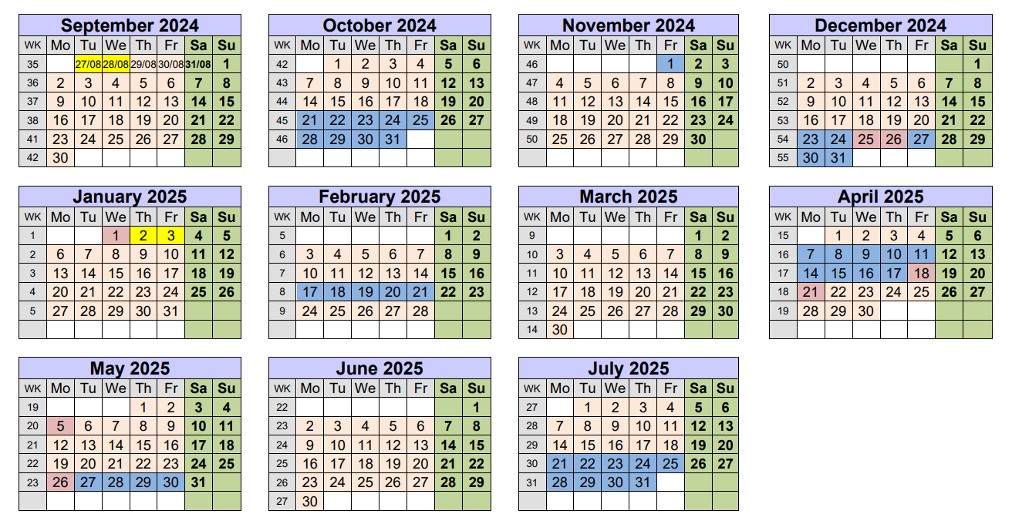
September 2025 |  |  |  |  |  |  |  |  | October 2025 |  |  |  |  |  |  |  |  | November 2025 |  |  |  |  |  |  |  |  | December 2025
WK | Mo | Tu | We | Th | Fr | Sa | Su |  | WK | Mo | Tu | We | Th | Fr | Sa | Su |  | WK | Mo | Tu | We | Th | Fr | Sa | Su |  | WK | Mo | Tu | We | Th | Fr | Sa | Su
 | 25/8 | 26/8 | 27/8 | 28/8 | 29/8 | 30/8 | 31/8 |  | 39 |  |  | 1 | 2 | 3 | 4 | 5 |  | 43 |  |  |  |  |  | 1 | 2
35 | 1 | 2 | 3 | 4 | 5 | 6 | 7 |  | 40 | 6 | 7 | 8 | 9 | 10 | 11 | 12 |  | 44 | 3 | 4 | 5 | 6 | 7 | 8 | 9 |  | 48 | 1 | 2 | 3 | 4 | 5 | 6 | 7
36 | 8 | 9 | 10 | 11 | 12 | 13 | 14 |  | 41 | 13 | 14 | 15 | 16 | 17 | 18 | 19 |  | 45 | 10 | 11 | 12 | 13 | 14 | 15 | 16 |  | 49 | 8 | 9 | 10 | 11 | 12 | 13 | 14
37 | 15 | 16 | 17 | 18 | 19 | 20 | 21 |  | 42 | 20 | 21 | 22 | 23 | 24 | 25 | 26 |  | 46 | 17 | 18 | 19 | 20 | 21 | 22 | 23 |  | 50 | 15 | 16 | 17 | 18 | 19 | 20 | 21
38 | 22 | 23 | 24 | 25 | 26 | 27 | 28 |  | 43 | 27 | 28 | 29 | 30 | 31 |  |  |  | 47 | 24 | 25 | 26 | 27 | 28 | 29 | 30 |  | 51 | 22 | 23 | 24 | 25 | 26 | 27 | 28
39 | 29 | 30 |  |  |  |  |  |  |  |  |  |  |  |  |  |  |  |  |  |  |  |  |  |  |  |  | 52 | 29 | 30 | 31
January 2026 |  |  |  |  |  |  |  |  | February 2026 |  |  |  |  |  |  |  |  | March 2026 |  |  |  |  |  |  |  |  | April 2026
WK | Mo | Tu | We | Th | Fr | Sa | Su |  | WK | Mo | Tu | We | Th | Fr | Sa | Su |  | WK | Mo | Tu | We | Th | Fr | Sa | Su |  | WK | Mo | Tu | We | Th | Fr | Sa | Su
1 |  |  |  | 1 | 2 | 3 | 4 |  | 5 |  |  |  |  |  |  | 1 |  | 9 |  |  |  |  |  |  | 1 |  | 14 |  |  | 1 | 2 | 3 | 4 | 5
2 | 5 | 6 | 7 | 8 | 9 | 10 | 11 |  | 6 | 2 | 3 | 4 | 5 | 6 | 7 | 8 |  | 10 | 2 | 3 | 4 | 5 | 6 | 7 | 8 |  | 15 | 6 | 7 | 8 | 9 | 10 | 11 | 12
3 | 12 | 13 | 14 | 15 | 16 | 17 | 18 |  | 7 | 9 | 10 | 11 | 12 | 13 | 14 | 15 |  | 11 | 9 | 10 | 11 | 12 | 13 | 14 | 15 |  | 16 | 13 | 14 | 15 | 16 | 17 | 18 | 19
4 | 19 | 20 | 21 | 22 | 23 | 24 | 25 |  | 8 | 16 | 17 | 18 | 19 | 20 | 21 | 22 |  | 12 | 16 | 17 | 18 | 19 | 20 | 21 | 22 |  | 17 | 20 | 21 | 22 | 23 | 24 | 25 | 26
5 | 26 | 27 | 28 | 29 | 30 | 31 |  |  | 9 | 23 | 24 | 25 | 26 | 27 | 28 |  |  | 13 | 23 | 24 | 25 | 26 | 27 | 28 | 29 |  | 18 | 27 | 28 | 29 | 30
 |  |  |  |  |  |  |  |  |  |  |  |  |  |  |  |  |  | 14 | 30 | 31
May 2026 |  |  |  |  |  |  |  |  | June 2026 |  |  |  |  |  |  |  |  | July 2026
WK | Mo | Tu | We | Th | Fr | Sa | Su |  | WK | Mo | Tu | We | Th | Fr | Sa | Su |  | WK | Mo | Tu | We | Th | Fr | Sa | Su
18 |  |  |  |  | 1 | 2 | 3 |  | 23 | 1 | 2 | 3 | 4 | 5 | 6 | 7 |  | 27 |  |  | 1 | 2 | 3 | 4 | 5
19 | 4 | 5 | 6 | 7 | 8 | 9 | 10 |  | 24 | 8 | 9 | 10 | 11 | 12 | 13 | 14 |  | 28 | 6 | 7 | 8 | 9 | 10 | 11 | 12
20 | 11 | 12 | 13 | 14 | 15 | 16 | 17 |  | 25 | 15 | 16 | 17 | 18 | 19 | 20 | 21 |  | 29 | 13 | 14 | 15 | 16 | 17 | 18 | 19
21 | 18 | 19 | 20 | 21 | 22 | 23 | 24 |  | 26 | 22 | 23 | 24 | 25 | 26 | 27 | 28 |  | 30 | 20 | 21 | 22 | 23 | 24 | 25 | 26
22 | 25 | 26 | 27 | 28 | 29 | 30 | 31 |  | 27 | 29 | 30 |  |  |  |  |  |  | 31 | 27 | 28 | 29 | 30 | 31

