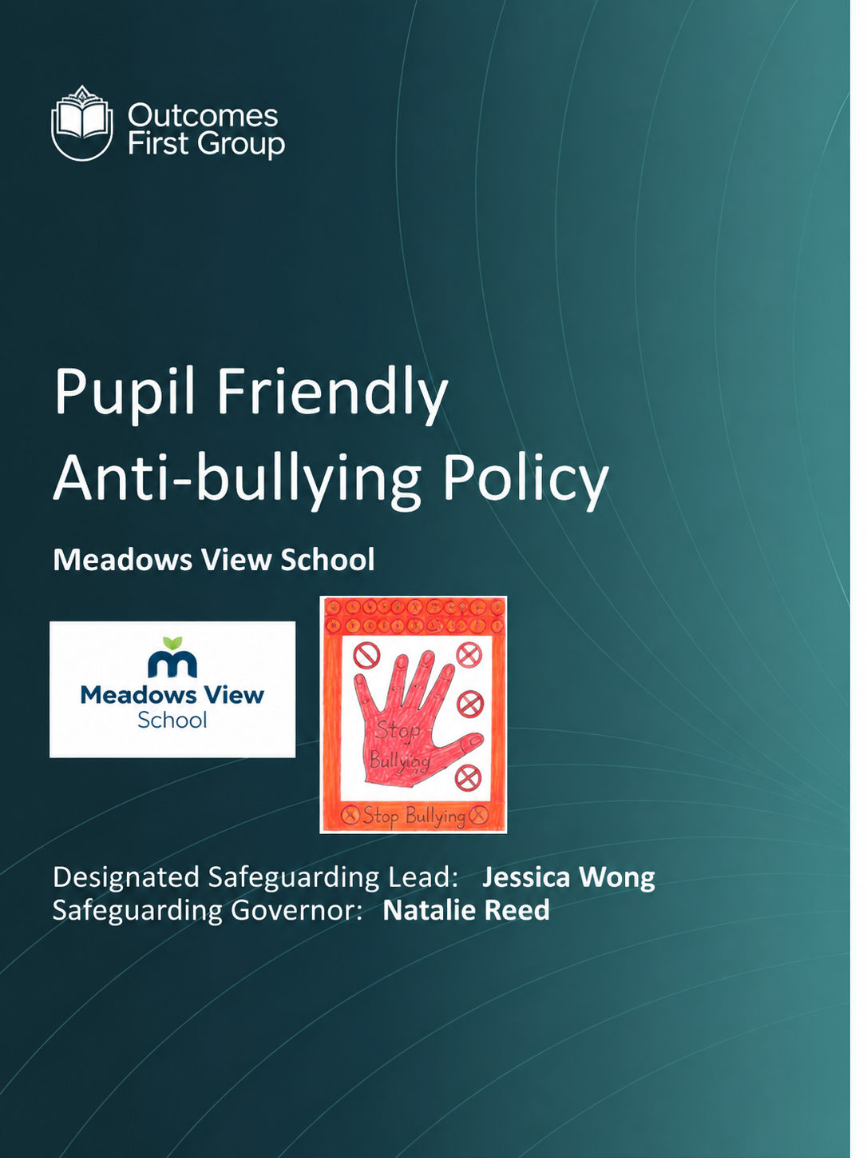


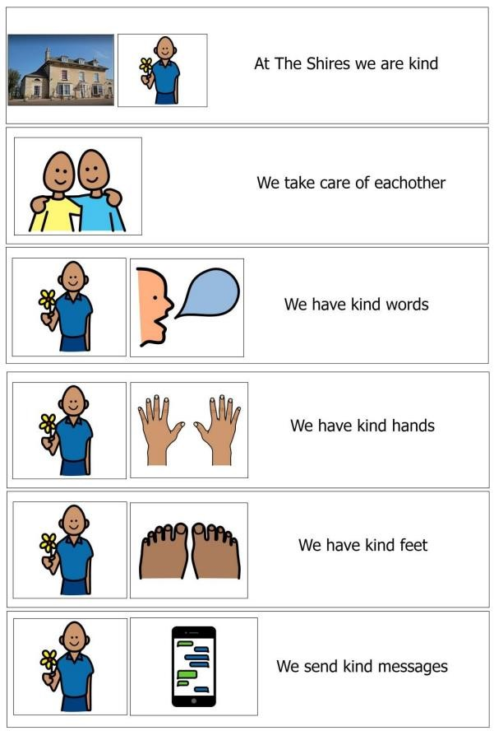
At Meadows View we are kind
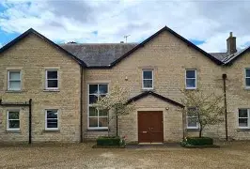
We take care of each other

Document Name: Anti-bullying Policy (Pupil Friendly) Document Type: Policy Policy Owner: DSL Date First Issued: Dec 2025 Version Number: 1.0 Review Date: Dec 2026

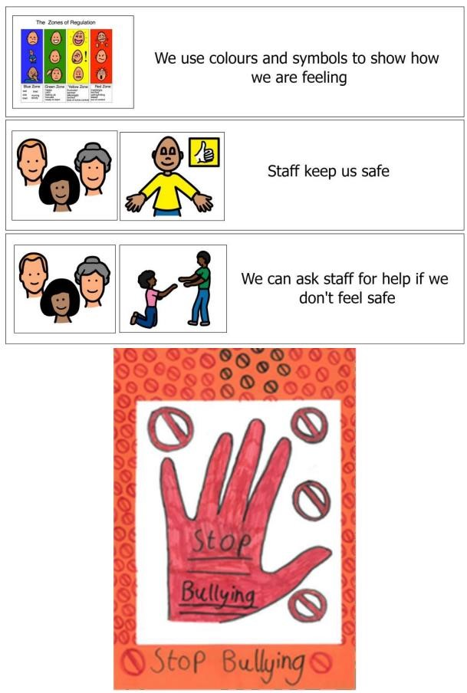
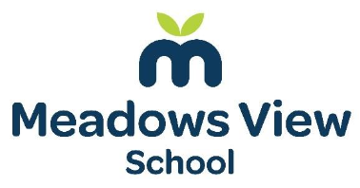

Document Name: Anti-bullying Policy (Pupil Friendly) Document Type: Policy Policy Owner: DSL
Date First Issued: Dec 2025 Version Number: 1.0 Review Date: Dec 2026


